**DELIVERABLE 1- PROPOSAL**

**Project Title:**

Android Women safety app

**Group Name:**

Softwareengineering_project

**Group Members:**

1. Krishna Sai Ujwal Kambhpati (Group Leader)
2. Sharan Kumar Pallapu
3. Vineesha Sangepu
4. Praveen Reddy Talupu

5. Vineela Pamarthi

6. Jayakanth Madineni

7. Sai Tai Prathyusha Garikapati

**Project Description:**

It is dangerous to go out at night, particularly if you're a woman in today's environment, it’s long past time for women to stop travelling alone, because they can't defend themselves as well as males can. In order to lessen the likelihood of being a victim of violent crime we need something that can help them in difficult times. Women can use this application to protect themselves in the time of danger and this application lets the user to not only alert the emergency contact but also to share the location to let the other person track the user.

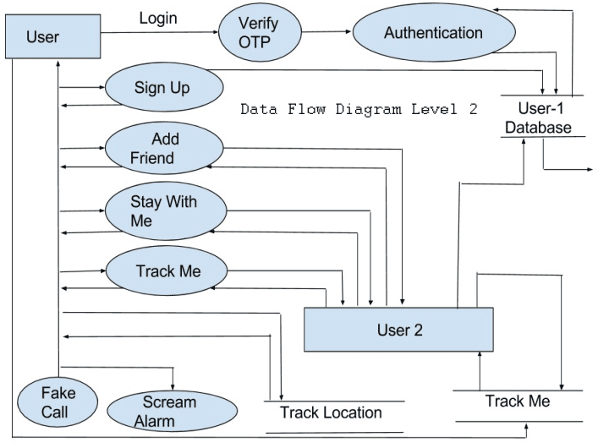

**Development Environment**

The following are the hardware and software requirement used to develop this application.

1. **Hardware Requirements:**

* Intel i5 process and above
* RAM 8 GB and above
* HD 100 GB and above
* GPU GTX 1080 and above

1. **Software Requirements:**

* IDE : Android studio
* Front End Language: XML
* Back End Language: Java, Android

**Project Timeline:**

The project timeline consists of Modules, Functionalities, planning and Gantt Chart of the project.

**Modules / Features of Project**

1. **Detailed instruction page**

This page consists all the instructions of the app. It helps user to understand the functionality of the app and helps them how to use the app.

1. **Add contact detail**

In this module, the user can add the contact detail of the person whom they want to put as emergency contact. By clicking on add contact detail, user can enter the mobile number.

1. **Remove contact**

In this module, user can delete or remove the saved contact details which helps the user to change the emergency contact by removing and adding a new one.

1. **Add profile name**

This function helps the user to add a name to their profile which will help the user to identify themselves.

1. **Emergency contact number calling feature**

This feature enables the user to call the emergency contact number by clicking on the button.

1. **SOS button**

This feature is used to send a message to the emergency contact by clicking on the SOS button. We can send a default message which will lessen the time.

1. **Live location tracking button**

This module is implemented to let the user share their live location which will help the emergency contact to track the user**.**

1. **Emergency contact message sharing button.**

* The project can be installed in large women population phones to support tracking.
* The System admin will be able to run real time and give support if required.

**Functional Requirements**

* The messaging app's functionality is dissected, and our findings are presented. Unless they actively ask for help, they will only be contacted via the means they currently have on file.
* Using SMS tracking updates, the victim's exact position may be identified rapidly and securely. The motivation for this idea is the need to ensure the safety of women.
* To that end, it is important to take into account the specific dangers faced by modern women. With all of the safeguards in place, women can be certain that they will never be placed in harm's way. system.

**Planning:**

Planning, analysis, design, implementation, testing, and maintenance phases are all included in our project's many phases. Each phase's benchmarks are.

1) Planning

1. Selecting a project concept with the team.

2. Assessing project-related competencies of team members.

3. Depending on the skills, making customized plans for team members.

4. Choosing the appropriate IDE, language, and platform.

5. Making an action plan for the undertaking.

2) Evaluation

1. Data analysis and gathering for the project.

2. Complete the project specifications and carry out the feasibility assessment.

3) Creation

1. Discovering the project's requirements.

2. Creating a drawing of every application's user interface.

3. Creating android app and view styles.

4) Application

1. Making the user interface for android based on the design interface.

2. Implementing the modules and using java to implement the logic to produce fully functional application.

5. Using example data to test the code.

6. Verify that all of the features have been implemented.

5) Examining

1. Check the application's functionality by testing it with all available data.

2. Verifying incorrect inputs for mistakes.

3. Checking that form controls accept the right data.

3. Creating test cases to determine if the programs are giving accurate results.

**GANTT Chart:**

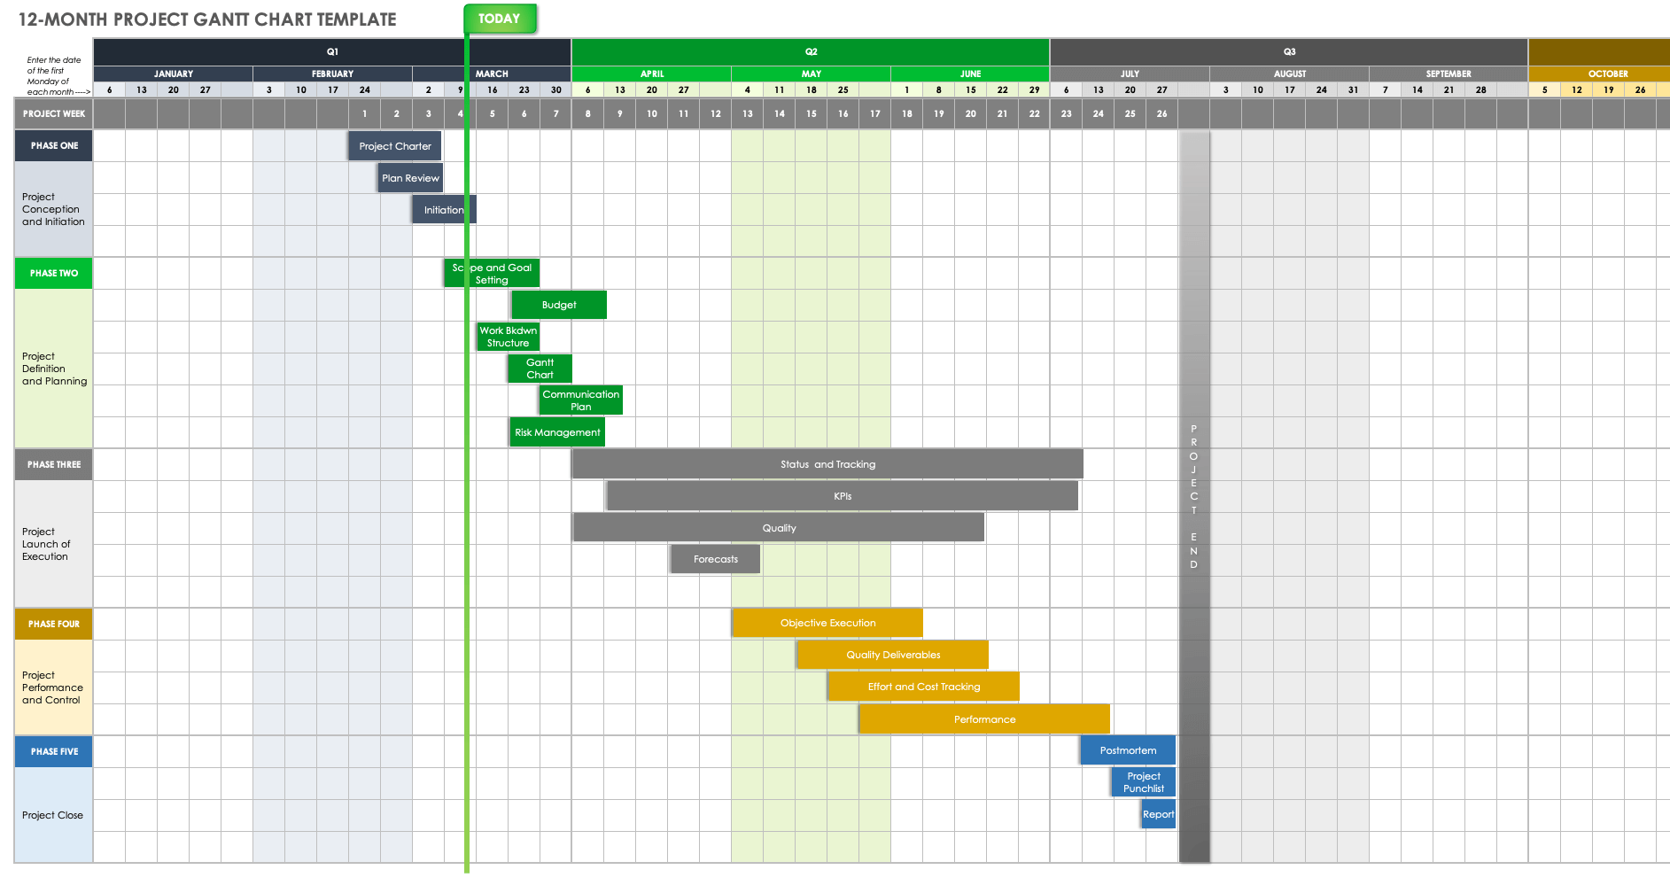

**Risk Management:**

In our group discussion while analysing the project requirements we identified the following major risks.

1.Lack of knowledge in java programming for few members in team to accomplish certain tasks

2.Unable to work on non-internet locations.

3.Accuracy needs improvement

4.Developing the application by a group of people at different timings and schedules will lead to delay in achieving the tasks and deliverables.

**Team Roles:**

* Krishna Sai Ujwal Kambhpati (Group Leader): Design of the UI, the design of user experiences
* Vineesha Sangepu: Creation of flow diagrams and code optimisation
* Praveen Reddy Talupu: Designing backend
* Vineela Pamarthi: Designing of documentation , content creation
* Jayakanth Madineni : Logic development and backend
* Sharan Kumar Pallapu: Server connection and documentation
* Sai Tai Prathyusha Garikapati: Connecting teams and frontend designs

**Member Contribution Table (For Deliverable 1):**

|  |  |  |  |
| --- | --- | --- | --- |
| Member Name | Contribution Description | Overall Contribution | Note |
| Krishna Sai Ujwal Kambhpati | Design of the UI, the design of user experiences  As leader of the team, I have discussed the project ideas with the team and organized zoom meetings. | 15% |  |
| Vineesha Sangepu | Creation of flow diagrams and code optimisation. I have worked on deciding the project idea, planning and deciding a schedule for upcoming weeks. | 13% |  |
| Praveen Reddy Talupu | Designing backend. I have attended the zoom meetings and discussed on the functionalities and modules to be included in the project. | 12% |  |
| Vineela Pamarthi | Designing of documentation , content creation. I have worked on github readme file and on meeting minutes file. | 12% |  |
| Jayakanth Madineni | Logic development and backend. I have also worked on preparing the presentation, creating the gantt chart and contributed my thoughts for the risk management. | 12% |  |
| Sharan kumar pallapu | Server connection and documentation. I have also worked on gantt chart and gathered all the information required for the modules. I have made the final changes to the ppt. | 12% |  |
| Sai Tai Prathyusha Garikapati | Connecting teams and frontend designs.  I have shared few ideas about the implementation and worked on few modules and helped submitting all documents in canvas. | 12% |  |